05.04.2016

**Implementation of Harmonic Resonance Modal Analysis**

I have implemented that method (on the basis of eigenvalues, small signals etc.) that I had mentioned - Resonance Harmonics Modal Analysis for three cases which I was using before.

In this method the results are the basically plots of modal impedance in domain of harmonic order for different modes, but only some of them (modes) are responsible for harmonics (these does not correspond directly to buses or elements – it is modal domain). There is no bus that we can “see” impedance from, but instead, to identify buses that participate in the harmonics, we can use left and right eigenvalue vectors of admittance matrix to obtain “participation factors” for each bus. Buses are numbered like below:

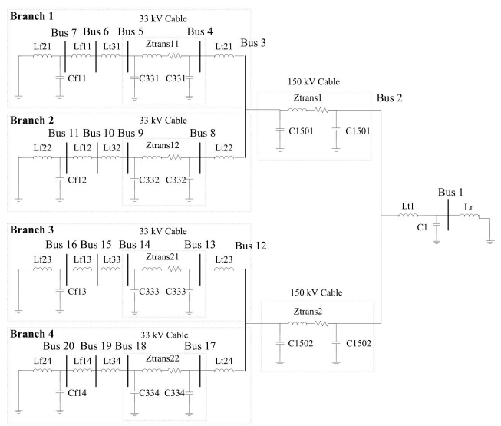

For first case (1 Wind Turbine) the admittance matrix 7x7 is calculated, for second (2 WTs): 11x11, and for third (4 WTs): 20x20. The results are 7, 11 or 20 modes and couple of them are identified as critical.

Below you can see, for each case, plotted results of: 1) frequency sweep 2) harmonic modal analysis - all modes 3) HMA – maximal modes (only max modal impedances for each harmonics) for each harmonic 4) HMA - Critical modes (max modal impedances from ALL harmonics). Moreover, some numerical output like participation factors (0<PF<1) of buses in the tables below graphs.

CASE 1 (one WT):

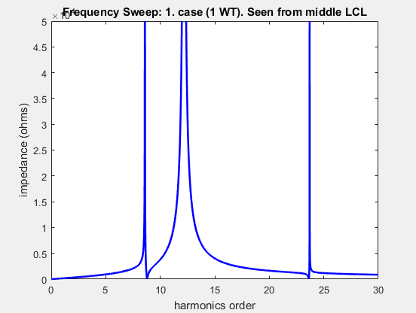 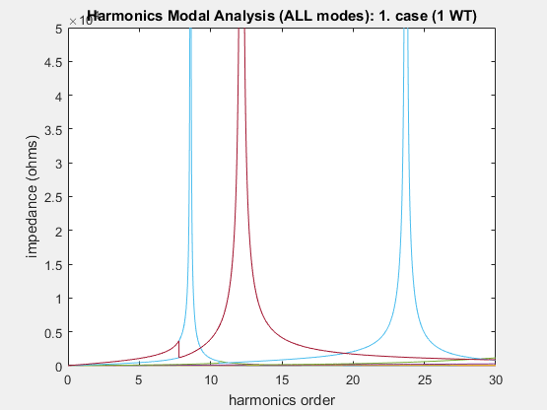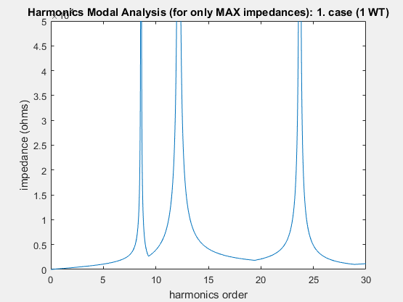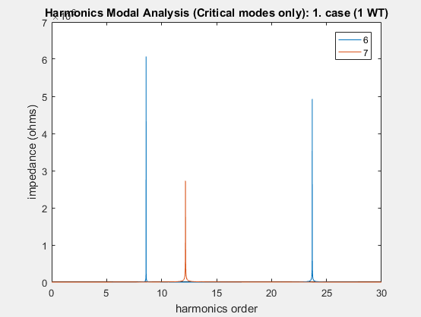

--------------- CASE 1 (1 WT); resolution: 0.010000 ---------------

ZmodalHcrit =

h. order mode modal impedance angle

8.59 6 6.0716e+06 -79.947

12.17 7 2.7263e+06 -81.311

23.7 6 4.9283e+06 -20.486

Participation factors for all buses (1-7):

0.088472 0.12849 0.12979 0.14214 0.14595 0.15061 0.21454

0.0014906 0.00024154 0.00020251 0.0016529 0.0043349 0.018072 0.97401

0.0088408 0.14599 0.15657 0.23111 0.2431 0.20026 0.014132

Greatest participation factors:

**For harmonic: 8.590000, bus: 7.000000 has greatest PF=0.214542**

**For harmonic: 12.170000, bus: 7.000000 has greatest PF=0.974006**

**For harmonic: 23.700000, bus: 5.000000 has greatest PF=0.243103**

CASE 2 (two WTs):

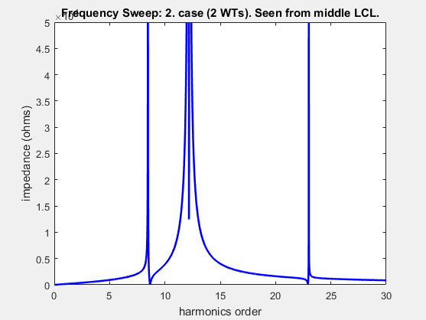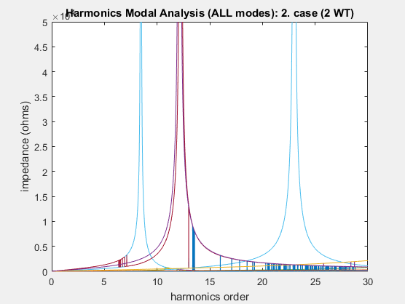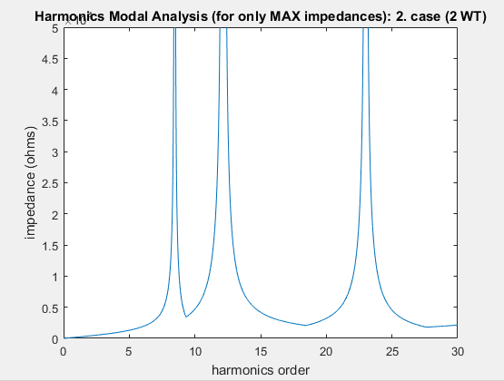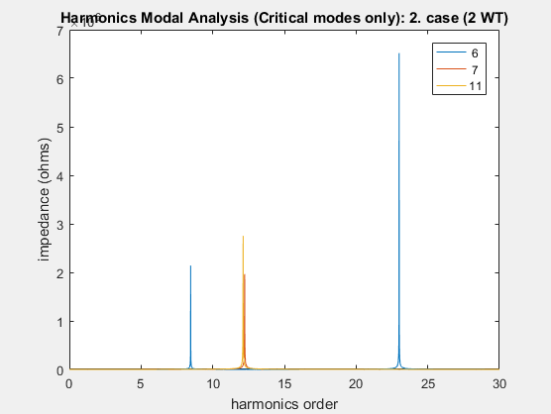

--------------- CASE 2 (2 WT); resolution: 0.010000 ---------------

harmonic order - critical mode - modal impedance(abs) - angle

ZmodalHcrit =

h. order mode modal impedance angle

8.46 6 2.1401e+06 -86.742

12.12 11 2.7533e+06 82.359

12.23 7 1.9653e+06 82.98

23 6 6.5168e+06 20.28

harmonic order - participation factors for all buses (1-11)

Columns 1 through 8

0.052512 0.079324 0.080273 0.087421 0.08958 0.09202 0.12492 0.087421

9.3724e-34 1.7272e-34 1.4972e-34 0.0015021 0.0031803 0.010819 0.4845 0.0015021

0.0028811 0.00043106 0.00035723 0.00039599 0.0014315 0.0075803 0.48876 0.00039599

0.0064521 0.088834 0.095806 0.1361 0.14202 0.11657 0.0097629 0.1361

Columns 9 through 11

0.08958 0.09202 0.12492

0.0031803 0.010819 0.4845

0.0014315 0.0075803 0.48876

0.14202 0.11657 0.0097629

greatest participation factors:

**For harmonic: 8.460000, bus: 7 has greatest PF=0.124924.**

**(also same PF at buses: 11)**

**For harmonic: 12.120000, bus: 7 has greatest PF=0.484498.**

**(also same PF at buses: 11)**

**For harmonic: 12.230000, bus: 11 has greatest PF=0.488758.**

**(also same PF at buses: 7)**

**For harmonic: 23.000000, bus: 9 has greatest PF=0.142016.**

**(also same PF at buses: 5)**

CASE 3 (4 WTs):

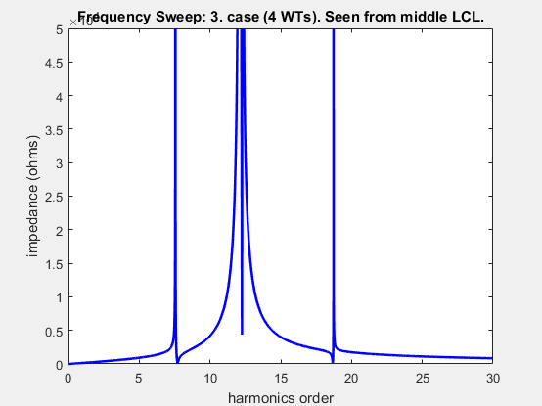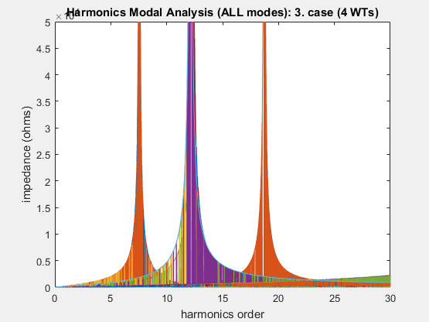

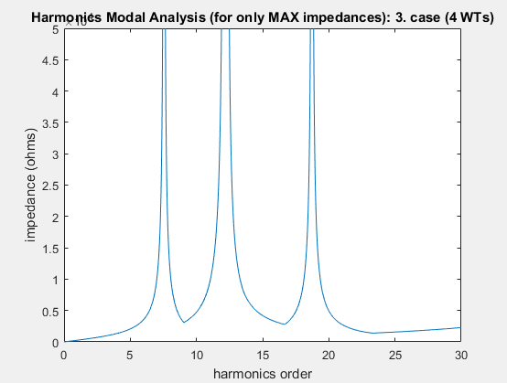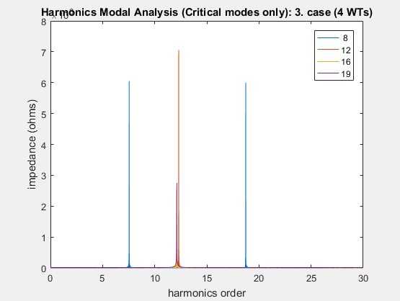

--------------- CASE 3 (4 WT); resolution: 0.010000 ---------------

ZmodalHcrit =

h. order mode modal impedance angle

7.55 8 6.0508e+06 -83.368

12.1 16 2.4842e+06 -80.84

12.12 19 2.7533e+06 82.359

12.3 12 7.0504e+06 64.492

18.73 8 5.9968e+06 57.46

harmonic order - participation factors for all buses (1-20):

Columns 1 through 8

0.02512 0.048284 0.048698 0.051247 0.051864 0.051898 0.052291 0.051247

4.2398e-33 8.4348e-34 2.0391e-06 0.00083127 0.0017041 0.0055997 0.24186 0.00083127

6.0814e-33 9.5854e-34 1.6765e-31 0.0015362 0.0032525 0.011065 0.49548 0.0015362

0.0041899 0.00056812 0.00051044 2.3279e-05 0.00031113 0.0028312 0.24539 2.3279e-05

0.017412 0.055565 0.058073 0.067006 0.066541 0.052498 0.016674 0.067006

Columns 9 through 16

0.051864 0.051898 0.052291 0.048698 0.051247 0.051864 0.051898 0.052291

0.0017041 0.0055997 0.24186 2.0391e-06 0.00083127 0.0017041 0.0055997 0.24186

0.0032525 0.011065 0.49548 1.8274e-31 6.0296e-05 0.00012766 0.00043429 0.019448

0.00031113 0.0028312 0.24539 0.00051044 2.3279e-05 0.00031113 0.0028312 0.24539

0.066541 0.052498 0.016674 0.058073 0.067006 0.066541 0.052498 0.016674

Columns 17 through 20

0.051247 0.051864 0.051898 0.052291

0.00083127 0.0017041 0.0055997 0.24186

6.0296e-05 0.00012766 0.00043429 0.019448

2.3279e-05 0.00031113 0.0028312 0.24539

0.067006 0.066541 0.052498 0.016674

greatest participation factors:

**For harmonic: 7.550000, bus: 7 has greatest PF=0.052291.**

**(also same PF at buses: 11 16 20)**

**For harmonic: 12.100000, bus: 7 has greatest PF=0.241864.**

**(also same PF at buses: 11 16 20)**

**For harmonic: 12.120000, bus: 11 has greatest PF=0.495483.**

**(also same PF at buses: 7)**

**For harmonic: 12.300000, bus: 7 has greatest PF=0.245390.**

**(also same PF at buses: 11 16 20)**

**For harmonic: 18.730000, bus: 17 has greatest PF=0.067006.**

**(also same PF at buses: 4 8 13)**

As you see the results are very similar (same frequencies) with frequency sweep and harmonic resonance modal analysis. Moreover, seems like HRMA gives participation factors that are more accurate for identification of elements/buses than my analysis of frequency sweep, however the results of both approaches corresponds somehow to each other. In some papers HRMA is used for identification of probable place for installing of filters, however the results are never taken as an “oracle”, and usually are further evaluated by other calculations. I wonder if I should stay with those cases or look for other exemplary wind farm. Since my codes in matlab now are quite universal, the challenge is mainly with implementation of admittance matrix.

**Comparison between results of models with current source (open-circuit) and voltage source (short-circuit):**

I think, also quite important task that should be investigated more is the modelling of converter itself i.e. at least for analysis like above. What I mean is more or less what you asked about last time i.e. whether use voltage or current source (short- or open-circuit). Look at the results of models with voltage sources and current sources (only for 1 case as an example). I have modelled these cases in matlab in both frequency sweep and HRMA, but also in DIgSILENT.

This modification frequency sweep is that the last impedance (Lf 21) is connected in series instead of in parallel, admittance matrix is extended by the 8. bus between new current source (open-circuit) and Lf 21.

Differences are quite significant. For 3. case, differences are even bigger (haven’t compered it in matlab yet, but DIgSILENT shows that they are more different). I have talked about it today with Oriol and he has mentioned some sort approaches to this problem , for example modelling converter as both current AND voltage source depending what harmonics we are modelling etc. I have no idea how, so far, but I will search for some information about it.

1.Case (one WT): Voltage Source (short-circuit/grounding):

 

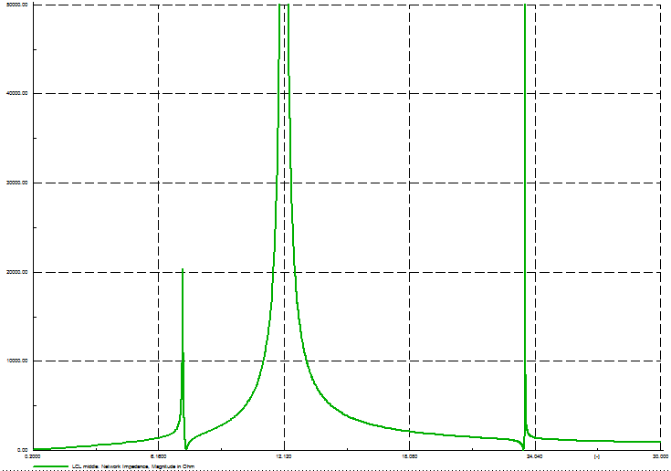

* Harmonics n DIgSILENT: **7.3, 12.1, 23.5**
* MATLAB:

--------------- CASE 1 (1 WT); resolution: 0.010000 ---------------

harmonic order - critical mode - modal impedance(abs) - angle

**8.59** 6 6.0716e+06 -79.947

**12.17** 7 2.7263e+06 -81.311

**23.7** 6 4.9283e+06 -20.486

harmonic order - participation factors for all buses (1-7)

0.088472 0.12849 0.12979 0.14214 0.14595 0.15061 0.21454

0.0014906 0.00024154 0.00020251 0.0016529 0.0043349 0.018072 0.97401

0.0088408 0.14599 0.15657 0.23111 0.2431 0.20026 0.014132

greatest participation factors:

For harmonic: 8.590000, bus: 7.000000 has greatest PF=0.214542

For harmonic: 12.170000, bus: 7.000000 has greatest PF=0.974006

For harmonic: 23.700000, bus: 5.000000 has greatest PF=0.243103

1.Case (one WT): Current source (open-circuit):

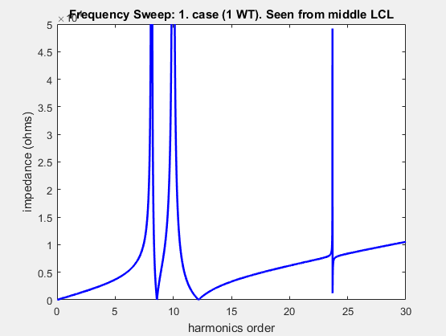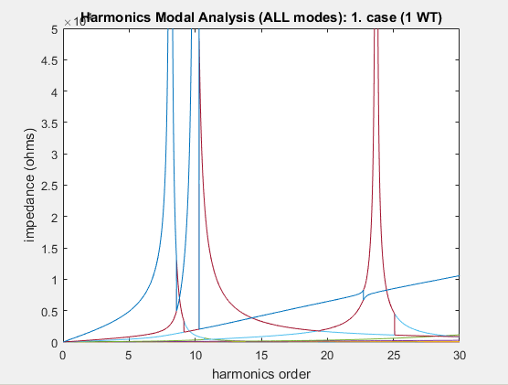

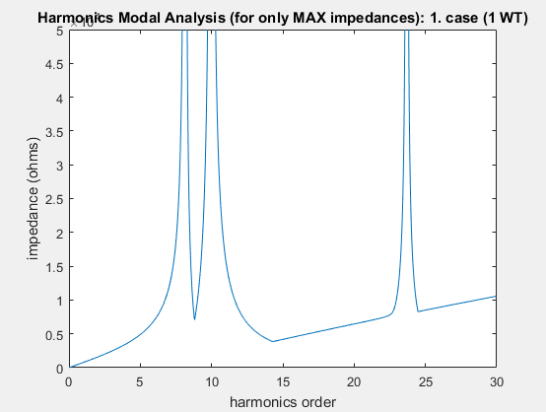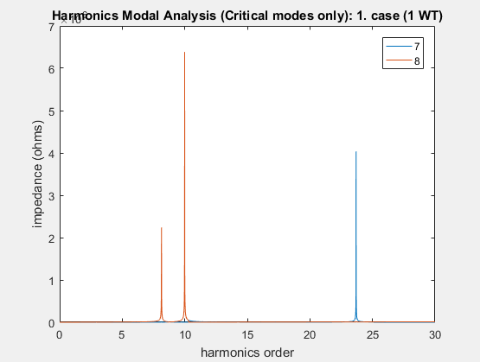

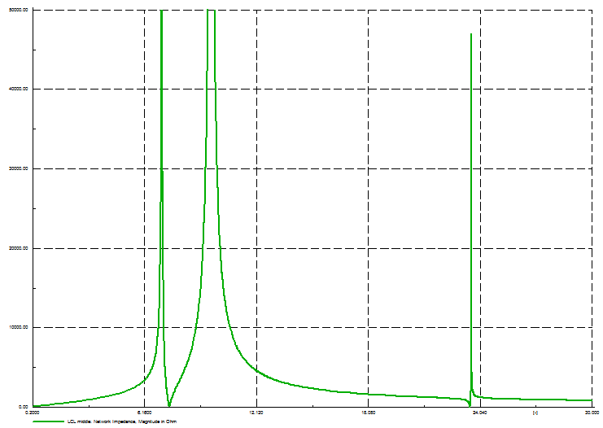

* Harmonics n DIgSILENT: **7.0, 9.7, 23.6**
* Matlab:

--------------- CASE 1 (1 WT); resolution: 0.010000 ---------------

harmonic order - critical mode - modal impedance(abs) - angle

**8.14** 8 2.2409e+06 84.603

**9.99** 8 6.3861e+06 74.489

**23.69** 7 4.0356e+06 -40.452

harmonic order - participation factors for all buses

0.015955 0.026406 0.026836 0.037359 0.042366 0.056386 0.39789 0.3968

0.005679 0.0048514 0.004761 0.00090725 0.0001331 0.0017231 0.49125 0.49069

0.0087563 0.14423 0.1547 0.22923 0.24149 0.1999 0.010835 0.010866

greatest participation factors:

For harmonic: 8.140000, bus: 7.000000 has greatest PF=0.397887

For harmonic: 9.990000, bus: 7.000000 has greatest PF=0.491252

For harmonic: 23.690000, bus: 5.000000 has greatest PF=0.241491

I believe, I should maybe look closer to the modelling of converters, not only because of the differences above, but also as the next step of the thesis… Since, from the HRMA method some identification of buses is obtained, also sort of filtering implementation is possible now. What do you think? Thanks.